Deflection of beams
We have already derived the pure bending equation for symmetric, prismatic, homogeneous beams as ${ σ}_{xx}=\frac{-E}{ρ}y=-\frac{M_{z}}{I_{zz}}y$
$$\frac{1}{ρ}=\frac{M_{z}}{{EI}_{zz}}$$  Let $v$ be the deflection of the beam from x-axis downwards. Then $v=f(x)$ is the equation of the elastic curve. From the elementary calculus, the equation for curvature is $\frac{1}{ρ}=\frac{\frac{d^{2}v}{dx^{2}}}{{\left\{1+{\left(\frac{dv}{dx}\right)}^{2}\right\}}^{\frac{3}{2}}}$  For small deformations, the deflection curve is shallow. The slope $\frac{dv}{dx}=\tan{θ}≅θ$(in radians) is small. Then ${\left(\frac{dv}{dx}\right)}^{2}$ is still smaller. Then $1+{\left(\frac{dv}{dx}\right)}^{2}≅1$. | 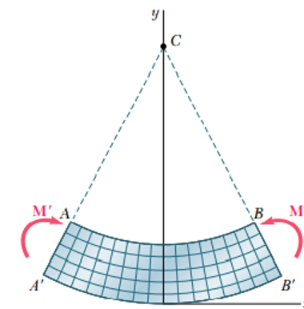  $$v$$  $$z$$  $$y$$  $$x$$
$$\frac{1}{ρ}=\frac{d^{2}v}{dx^{2}}=\frac{M_{z}}{{EI}_{zz}}$$
The second order differential equation ${EI}_{zz}\frac{d^{2}v}{dx^{2}}=M_{z}$ is the equation for the elastic curve.
Example 1  Determine the slope and deflection of the cantilever beam loaded at the end. | 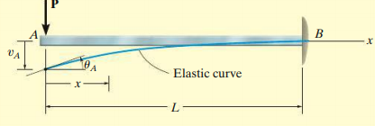
$$ΣM_{1-1}=0≪≫M+Px=0≫M=-Px$$  $${EI}_{zz}\frac{d^{2}v}{dx^{2}}=M_{z}=-Px$$ | $$P$$  $$V$$  $$M$$
Integrating with respect to x,
$$\int{{EI}_{zz}\frac{d^{2}v}{dx^{2}} dx=\int{-Px dx ≪≫ {EI}_{zz}\frac{dv}{dx}}}=-\frac{Px^{2}}{2}+C_{1}$$
Integrating again
$${EI}_{zz}v=-\frac{Px^{3}}{6}+C_{1}x+C_{2}$$
Substituting the boundary conditions: $At x=L, \frac{dv }{dx}=0 and v=0$
$$0=-\frac{PL^{2}}{2}+C_{1}≫≫ C_{1}=\frac{PL^{2}}{2}$$
$$0=-\frac{PL^{3}}{6}+\left(\frac{PL^{2}}{2}\right)L+C_{2}≫≫ C_{2}=-\frac{PL^{3}}{3}$$
$${EI}_{zz}\frac{dv}{dx}=-\frac{Px^{2}}{2}+\frac{PL^{2}}{2} ≪≫ {EI}_{zz}v=-\frac{Px^{3}}{6}+\left(\frac{PL^{2}}{2}\right)x-\frac{PL^{3}}{3}$$
At the free end of the cantilever beam, $x=0$
$$\frac{dv}{dx}=\frac{PL^{2}}{2{EI}_{zz}} ≪≫ v=-\frac{PL^{3}}{3{EI}_{zz}}$$

#Example 2  A simply supported beam with uniformly distributed load of intensity $w$ | 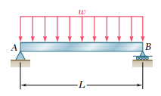
The total load is $wL$. The support reactions are $\frac{wL}{2}$. $$ΣM_{1-1}=0≪≫M-\frac{wL}{2}x+\frac{wx^{2}}{2}=0≫M=\frac{wL}{2}x-\frac{wx^{2}}{2}$$  $${EI}_{zz}\frac{d^{2}v}{dx^{2}}=M_{z}=\frac{wL}{2}x-\frac{wx^{2}}{2}$$ | 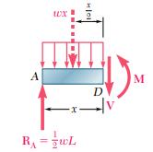
Integrating with respect to x,
$$\int{{EI}_{zz}\frac{d^{2}v}{dx^{2}} dx=\int{\left(\frac{wL}{2}x-\frac{wx^{2}}{2}\right) dx ≪≫ {EI}_{zz}\frac{dv}{dx}}}=\frac{wLx^{2}}{4}-\frac{wx^{3}}{6}{+C}_{1}$$
Integrating again
$${EI}_{zz}v=\frac{wLx^{3}}{12}-\frac{wx^{4}}{24}+C_{1}x+C_{2}$$
Substituting the boundary conditions: $At x=0, v=0 and at x=L, v=0$
$$0=C_{2}$$
$$0=\frac{wL^{4}}{12}-\frac{wL^{4}}{24}+C_{1}L≫≫ C_{1}=-\frac{wL^{3}}{24}$$
$${EI}_{zz}\frac{dv}{dx}=\frac{wLx^{2}}{4}-\frac{wx^{3}}{6}-\frac{wL^{3}}{24} ≪≫ {EI}_{zz}v=\frac{wLx^{3}}{12}-\frac{wx^{4}}{24}-\frac{wL^{3}}{24}x$$
When $x=L/2$
$$v=-\frac{5wL^{4}}{384{EI}_{zz}} ≪≫ \frac{dv}{dx}=0$$

Exercise 1
Determine the slope and deflection at the free end of a cantilever of length $L$ and carrying a uniformly distributed load of intensity $w N/m$.
Exercise 2
Determine the deflection of the beam at the centre of a simply supported beam loaded by a concentrated load P at its centre.

Macaulay’s Method
Macaulay’s singularity functions can be used to determine the deflection of beams, which can be written as | 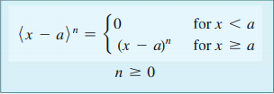
The integration of the Macaulay’s function follows the same rules as for ordinary functions. | 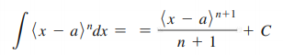
$$y$$
#Example 1  Determine the equation of the elastic curve for the beam loaded as shown. Also determine the slope and deflection at the free end of the beam. | 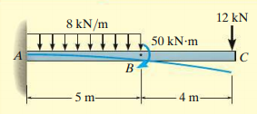  $$z$$  $$x$$  $$V_{1}$$  $$M_{1}$$  $$12kN$$
Section 1-1  $$ΣM_{1-1}=0≪≫{-M}_{1}-12x=0≫M_{1}=-12x$$  Section 2-2  $$ΣM_{2-2}=0≪≫{-M}_{2}-12x-50-8\frac{{\left(x-4\right)}^{2}}{2}=0$$  $$M_{2}=-12x-50-4{\left(x-4\right)}^{2}$$ | $$V_{2}$$  $$M_{2}$$  $$12kN$$  $$x$$  $$8kN/m$$  $$4m$$  $$50kNm$$  $$x$$
Now, we can write a single moment equation for the entire beam using the singularity functions
$$M=-12x-{50〈x-4〉}^{0}-4{〈x-4〉}^{2}$$
The deflection equation is
$${EI}_{zz}\frac{d^{2}v}{dx^{2}}=M_{z}=-12x-{50〈x-4〉}^{0}-4{〈x-4〉}^{2}$$
Integrating with respect to x,
$$\int{{EI}_{zz}\frac{d^{2}v}{dx^{2}} dx=\int{\left\{-12x-{50〈x-4〉}^{0}-4{〈x-4〉}^{2}\right\} dx }}$$
$${EI}_{zz}\frac{dv}{dx}=\frac{-12x^{2}}{2}{+C}_{1}-\frac{{50〈x-4〉}^{1}}{1}-\frac{{4〈x-4〉}^{3}}{3}$$
Integrating again
$${EI}_{zz}v=\frac{-6x^{3}}{3}+C_{1}x+C_{2}-\frac{{50〈x-4〉}^{2}}{2}-\frac{{4〈x-4〉}^{4}}{12}$$
Substituting the boundary conditions: $At x=9m, \frac{dv }{dx}=0 and v=0$
$$0=\frac{-12×9^{2}}{2}{+C}_{1}-\frac{{50(9-4)}^{1}}{1}-\frac{{4(9-4)}^{3}}{3}≫≫ C_{1}=902.7$$
$$0=\frac{-6{×9}^{3}}{3}+902.7×9+C_{2}-\frac{{50\left(9-4\right)}^{2}}{2}-\frac{{4\left(9-4\right)}^{4}}{12}≫≫ C_{2}=-5832$$
The equation for the slope of the elastic curve is
$${EI}_{zz}\frac{dv}{dx}=-6x^{2}+902.7-{50〈x-4〉}^{1}-{1.33〈x-4〉}^{3}$$
The equation of the elastic curve is
$${EI}_{zz}v=-2x^{3}+902.7x-5832-{25〈x-4〉}^{2}-{0.33〈x-4〉}^{4}$$
At the free end of the cantilever $(x=0)$
$$\frac{dv}{dx}=\frac{902.7}{{EI}_{zz}} ≪≫ v=\frac{-5832}{{EI}_{zz}}$$
$$8kN$$
#Example 2  Determine the deflections at C and D of the overhanging beam shown. | 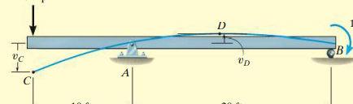  $$120kNm$$  $$20m$$  $$10m$$
Let us find out the support reactions first.  $$ΣF_{x}=0≫≫X=0$$  $$ΣM_{A}=0≫≫8×10+R×20-120=0$$  $$R=2 kN$$  $$ΣF_{y}=0≫≫Y+R-8=0 ≫≫Y=6 kN$$ |   $$8kN$$  $$R$$  $$Y$$  $$X$$  $$120kNm$$  $$20m$$  $$10m$$
Section 1-1  $$ΣM_{1-1}=0≪≫{+M}_{1}+8x=0≫M_{1}=-8x$$  Section 2-2  $$ΣM_{2-2}=0≪≫{+M}_{2}+8x-6\left(x-10\right)-120{\left(x-30\right)}^{0}=0$$  $$M_{2}=-8x+6\left(x-10\right)+120{\left(x-30\right)}^{0}$$  We know that there is a moment of $-120 kNm$ at $x=30 m$ |  | $$V_{1}$$  $$M_{1}$$  $$8kN$$  $$x$$  $$V_{2}$$  $$M_{2}$$  $$8kN$$  $$x$$  $$Y=6 kN$$
Hence, we can write a single moment equation for the entire beam using the singularity functions as
$$M=-8x+6{〈x-10〉}^{1}+120{〈x-30〉}^{0}$$
$${EI}_{zz}\frac{d^{2}v}{dx^{2}}=M_{z}=-8x+6{〈x-10〉}^{1}+120{〈x-30〉}^{0}$$
Integrating with respect to x,
$${EI}_{zz}\frac{dv}{dx}=\frac{-8x^{2}}{2}{+C}_{1}+\frac{{6〈x-10〉}^{2}}{2}+\frac{{120〈x-30〉}^{1}}{1}$$
Integrating again
$${EI}_{zz}v=\frac{-4x^{3}}{3}+C_{1}x+C_{2}+\frac{{3〈x-10〉}^{3}}{3}+\frac{{120〈x-30〉}^{2}}{2}$$
Substituting the boundary conditions: $At x=10m, v=0 and at x=30m, v=0$
$$0=\frac{-4{×10}^{3}}{3}+C_{1}×10+C_{2}≫≫ 10C_{1}+C_{2}=1333.3$$
$$0=\frac{-4{×30}^{3}}{3}+C_{1}×30+C_{2}+\frac{{3(30-10)}^{3}}{3}≫≫ 30C_{1}+C_{2}=28000$$
Solving, we get $C_{1}=1333.3, C_{2}=-12000$
The equation for the slope of the elastic curve is
$${EI}_{zz}\frac{dv}{dx}=-4x^{2}+1333.3+3{〈x-10〉}^{2}+120〈x-30〉$$
The equation of the elastic curve is
$${EI}_{zz}v=-1.33x^{3}+1333.3x-12000+{〈x-10〉}^{3}+{60〈x-30〉}^{2}$$
At the free end of the cantilever $(x=0)$
$$\frac{dv}{dx}=\frac{1333.3}{{EI}_{zz}} ≪≫ v_{c}=\frac{-12000}{{EI}_{zz}}$$
At D, deflection is maximum. Hence, the slope at D (which is at $x>10m)$ should be zero
$$0=-4x^{2}+1333.3+3{\left(x-10\right)}^{2}≫≫ x^{2}+60x-1633=0≫x=20.3 m$$
The deflection at D
$$v_{D}=\frac{+5030}{{EI}_{zz}}$$

#Example 3  Determine the slope and deflection of the cantilever beam shown. | $$8kN/m$$  $$5m$$  $$4m$$
The distributed load acting over 4m is assumed to be acting over the entire 9m downwards and acting over 5m upwards as shown (superposition) | $$8kN/m$$  $$8kN/m$$  $$5m$$  $$4m$$  $$8kN/m$$
Section 1-1  $$ΣM_{1-1}=0≪≫M_{1}+\frac{8x^{2}}{2}=0≫M_{1}=-4x^{2}$$  Section 2-2  $$ΣM_{2-2}=0≪≫M_{2}+\frac{8x^{2}}{2}-8\frac{{\left(x-4\right)}^{2}}{2}=0$$  $$M_{2}=-4x^{2}+4{\left(x-4\right)}^{2}$$ | $$V_{1}$$  $$M_{1}$$  $$x$$  $$M_{21}$$  $$8kN/m$$  $$V_{2}$$  $$x$$  $$4m$$  $$8kN/m$$
we can write a single moment equation for the entire beam using the singularity functions as
$$M=-4x^{2}+4{〈x-4〉}^{2}$$
$${EI}_{zz}\frac{d^{2}v}{dx^{2}}=M_{z}=-4x^{2}+4{〈x-4〉}^{2}$$
Integrating with respect to x,
$${EI}_{zz}\frac{dv}{dx}=\frac{-4x^{3}}{3}{+C}_{1}+\frac{{4〈x-4〉}^{3}}{3}$$
Integrating again
$${EI}_{zz}v=\frac{-4x^{4}}{12}+C_{1}x+C_{2}+\frac{{4〈x-4〉}^{4}}{12}$$
Substituting the boundary conditions: $At x=9m,\frac{dv}{dx}=0 and v=0$
$$0=\frac{-4{×9}^{3}}{3}+C_{1}+\frac{{4(9-4)}^{3}}{3}≫≫ C_{1}=805.3$$
$$0=\frac{-4{×9}^{4}}{12}+805.3×9+C_{2}+\frac{{4(9-4)}^{4}}{3}≫≫ C_{2}=-5894$$
The equation for the slope of the elastic curve is
$${EI}_{zz}\frac{dv}{dx}=\frac{-4x^{3}}{3}+805.3+\frac{{4〈x-4〉}^{3}}{3}$$
The equation of the elastic curve is
$${EI}_{zz}v=\frac{-4x^{4}}{12}+805.3x-5894+\frac{{4〈x-4〉}^{4}}{12}$$
At the free end of the cantilever $(x=0)$
$$\frac{dv}{dx}=\frac{805.3}{{EI}_{zz}} ≪≫ v=\frac{-5894}{{EI}_{zz}}$$

Exercise 1  Determine the slope and deflection of the cantilever beam at A and B | $$8kN/m$$  $$B$$  $$A$$  $$5m$$  $$4m$$  $$P$$
Exercise 2  Determine the slope and deflection of the beam directly under the load. What is the maximum deflection and where will it occur? | $$L$$  $$b$$  $$a$$
Exercise 3  Determine the maximum deflection of the beam loaded as shown. | 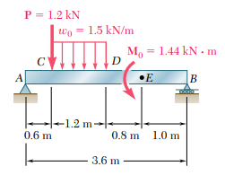
Exercise 4  Determine the reaction at A of the propped cantilever beam in terms of $P, a, L, E, and I$. What is the reaction at A and the deflection under the load when $a=\frac{L}{2}$? (Hint: Replace the roller support at A by the reaction $R_{A}$ and find the bending moment equation in terms of Macaulay’s functions and get the expression for slope and deflection as usual. The expressions will have three unknowns $C_{1}, C_{2}, and R_{A}.$ Substitute the three boundary conditions ${\left(v\right)}_{x=0}=0, {\left(v\right)}_{x=L}=0, and {\left(\frac{dv}{dx}\right)}_{x=L}=0$ to evaluate the unknowns.) |  | 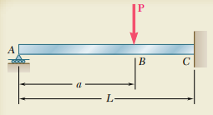  
Exercise 5  Determine the reaction at A of the propped cantilever beam in terms of $P, a, L, E, and I.$  (Hint: Replace the support at A by the reaction $R_{A}$ and moment and $M_{A}.$ Find the bending moment equation in terms of Macaulay’s functions and get the expression for slope and deflection as usual. The expressions will have four unknowns $C_{1}, C_{2}, M_{A}, and R_{A}.$ Substitute the four boundary conditions ${\left(v\right)}_{x=0}=0, {\left(v\right)}_{x=L}=0, {\left(\frac{dv}{dx}\right)}_{x=0}=0, and {\left(\frac{dv}{dx}\right)}_{x=L}=0$ to evaluate the unknowns.) |  | 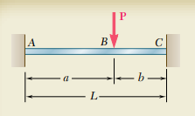  

Moment-Area Theorems
Consider a beam subjected to some arbitrary loading. The second figure represents the bending moment diagram scaled down by its flexural rigidity $\left(i.e., \frac{M}{EI} diagram\right)$.  The third figure shows the elastic deflection curve.  We know that the slope, $θ=\frac{dv}{dx}$  $$∴ \frac{d^{2}v}{dx^{2}}=\frac{M}{EI} ≫≫ \frac{dθ}{dx}=\frac{M}{EI}≫≫ dθ=\frac{M}{EI}dx$$  Considering two arbitrary points C and D on the beam and integrating from C to D  $$\int_{θ_{c}}^{θ_{D}}{dθ}=\int_{x_{c}}^{x_{D}}{\frac{M}{EI}dx}$$ | 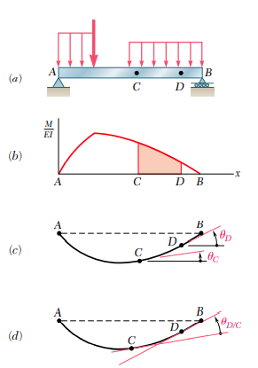
$${θ_{D}-θ}_{c}=\int_{x_{c}}^{x_{D}}{\frac{M}{EI}dx}$$
The angle between the tangents at D and C $\left(θ_{D/C}\right)$=Area of the $\frac{M}{EI}$ diagram between C and D. This is known as the first moment-area theorem.
Now consider twwo points P and P’located between C and D.The tangents to the elastic curve at P and P’ intersects the vertical through C making an intercept $dt$. Since $dθ$ is very small, we can write  $$dt=x_{1}dθ≫≫dt=x_{1}\frac{M}{EI}dx$$ | 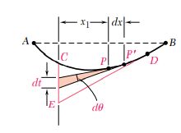
Now we need to integrate this equation from C to D.  As P moves from C to D, the tangent at P sweeps a distance CE along the vertical through C denoted by $t_{D/C}$ | 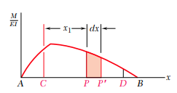
$$t_{D/C}=\int_{x_{c}}^{x_{D}}{\left(\frac{M}{EI}dx\right)x_{1}}$$  The vertical offset of point C from the tangent at D is equal to the first moment of the area under the $\frac{M}{EI}$ diagram between C and D with respect to the vertical axis through C.  $$t_{D/C}=(Area of \frac{M}{EI} diagrm)({\overline{x}}_{1})$$  This is known as the second moment area theorem. | 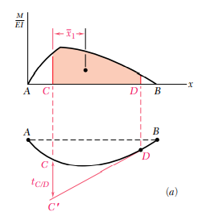

#Example 1  Determine the slope and deflection at B of the cantilever shown using moment-area method. Take EI as constant. | 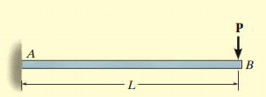
First draw the bending moment diagram and scale it down to $\frac{M}{EI}$  The first moment-area theorem states that  $${θ_{B/C}=θ}_{B}-θ_{A}=area of\frac{M}{EI} diagram between A \& B$$  $$θ_{B}-θ_{A}=\frac{1}{2}\left(\frac{-PL}{EI}\right)×L=-\frac{PL^{2}}{2EI}$$ | 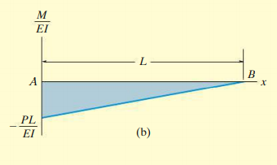
Since, $θ_{A}=0$, $θ_{B}=-\frac{PL^{2}}{2EI}$. Negative sign shows that the angle is measured clockwise.  According to the second moment-area theorem  $$t_{A/B}=(Area of \frac{M}{EI} diagram b/w A \&B)({\overline{x}}_{1})$$ | 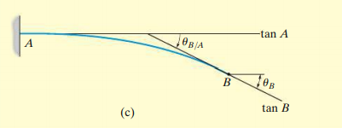  $$t_{A/B}$$
The vertical offset of point B from the tangent at A is equal to the first moment of the area of $\frac{M}{EI}$ diagram between A and B with respect to point B.
$$t_{A/B}=y_{B}=\left(-\frac{PL^{2}}{2EI}\right)×\frac{2L}{3}=-\frac{PL^{3}}{3EI}$$
#Example 2  Determine the deflection of point D of the simply supported beam shown. Also calculate the slope and deflection of point C. | 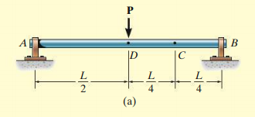
First sketch the bending moment diagram and scale it down to $\frac{M}{EI}$ diagram.  The vertical offset of point B from the tangent at D is equal to the first moment of the area of $\frac{M}{EI}$ diagram between D & B with respect to point B. | 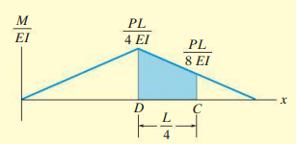
$$t_{D/B}=\left(+\frac{1}{2}×\frac{PL}{4EI}×\frac{L}{2}\right)×\frac{2}{3}\left(\frac{L}{2}\right)=+\frac{PL^{3}}{48EI}$$  $$y_{D}=-\frac{PL^{3}}{48EI}$$  $${θ_{C/D}=θ}_{C}-θ_{D}=area of\frac{M}{EI} diagram between C \& D$$  $$=\frac{1}{2}×\frac{L}{4}×\left(\frac{PL}{4EI}+\frac{PL}{8EI}\right)=\frac{3PL^{2}}{64EI}$$ | 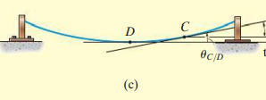  $$t_{D/B}$$
The vertical offset of point C from the tangent at D is equal to the first moment of the area of $\frac{M}{EI}$ diagram between D & C with respect to point C.
$$t_{D/C}=\left(\frac{PL}{8EI}×\frac{L}{4}\right)×\left(\frac{L}{8}\right)+\left(\frac{1}{2}×\frac{L}{4}×\frac{PL}{8EI}\right)×\frac{2}{3}\left(\frac{L}{4}\right)=+\frac{5PL^{3}}{768EI}$$
$$y_{C}=-\left(\frac{PL^{3}}{48EI}-\frac{5PL^{3}}{768EI}\right)=-\frac{11PL^{3}}{768EI}$$

Exercise 1  Determine the slope and deflection of point A of the beam with $E=200 GPa$ and $I=65×{10}^{-6} m^{4}$ | 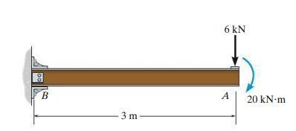
Exercise 2
Determine the slope and deflection of the free end of a cantilever beam of length $L$, flexural rigidity $EI$ carrying a udl of intensity $w N/m$ over the entire length.
Exercise 3  Determine the maximum deflection and slope at the ends of the simply supported beam shown | 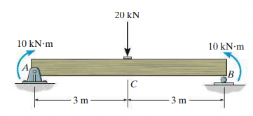
Exercise 4  Determine the slope and deflection of the beam at the free end. | $$L$$  $$L$$  $$2EI$$  $$EI$$

References
- Mechanics of Materials, 2/e, J. M. Gere & S. P.Timoshenko, CBS Publishers.
- Mechanics of Materials, 6/e, F.P. Beer & E. R. Johnston, McGraw Hill
- Engineering Mechanics of Solids, 2/e, E. P. Popov, Pearson Education Asia.
- Mechanics of Materials, 9/e, R. C. Hibbeler, Prentice Hall.

